vim deamonset.yaml

apiVersion: apps/v1

kind: DaemonSet

metadata:

name: ajay-deamonset

spec:

selector:

matchLabels:

name: ajay-deamon

template:

metadata:

labels:

name: ajay-deamon

spec:

containers:

- name: ajay-deamon

image: nginx

kubectl create –f deamonset.yaml

kubectl get nodes you see 3 nodes in ready state

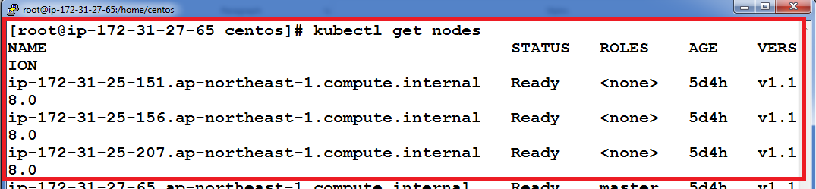

kubectl get pods

you should notice 3 pods are running as deamon on each node as we have 3 slave nodes because daemonset runs one copy of your app in each node exactly

